Lab plan No.6 Name: Muhammad Faizan Reg No.21-NTU-CS-1258

# Question No.1

## Input:

#include<iostream>

using namespace std;

float add(float a, float b, float =5, float =6, float =7);

float subtract(float a, float b, float =5, float =6, float =7);

float multiply(float a, float b, float =5, float =6, float =7);

int main()

{

int num1,num2;

cout<<"Enter First Number: ";

cin>>num1;

cout<<"Enter Second Number: ";

cin>>num2;

add(num1,num2);

subtract(num1,num2);

multiply(num1,num2);

}

float add(float a, float b, float c, float d, float e)

{

cout<<"The Addition of two input numbers and three default numbers is "<<a+b+c+d+e<<endl;

}

float subtract(float a, float b, float c, float d, float e)

{

cout<<"The subtract of two input numbers and three default numbers is "<<a-b-c-d-e<<endl;

}

float multiply(float a, float b, float c, float d, float e)

{

cout<<"The multiply of two input numbers and three default numbers is "<<a*b*c*d*e<<endl;

}

Output:  
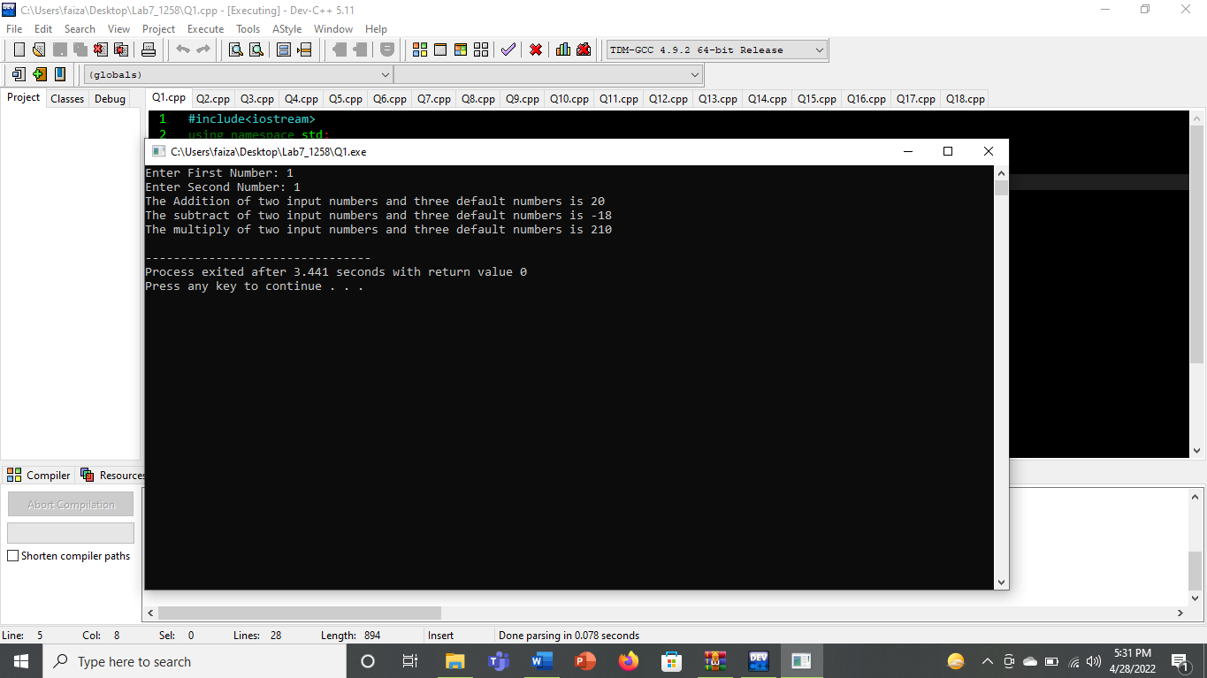

# Question No.2

## Input:

## #include<iostream>

## using namespace std;

## float avg(int a, int b,int c,int d, int e=0)

## {

## int sum,avg;

## sum=a+b+c+d+e;

## avg=sum/5;

## return (avg);

## }

## int main()

## {

## int a,b,c,d,e;

## cout<<"Enter five numbers for average "<<endl;

## cin>>a>>b>>c>>d>>e;

## cout<<"The average of number is "<<avg(a,b,c,d,e);

## }

## Output:

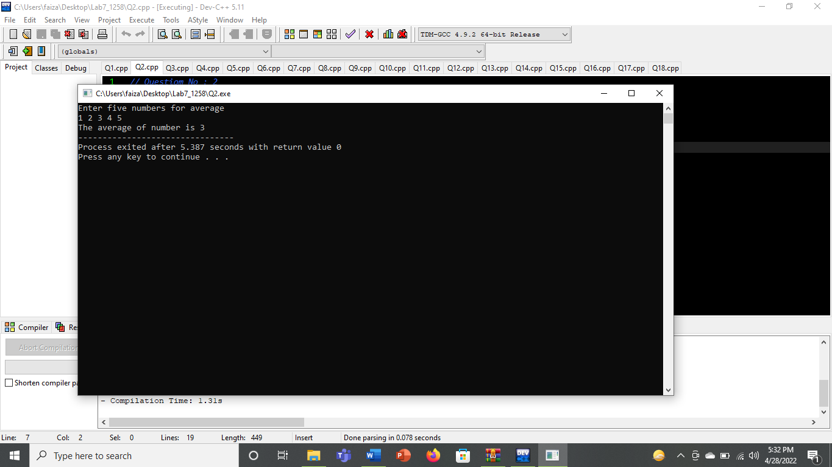

# Question No.3

## Input:

## #include<iostream>

## using namespace std;

## int add(int a,int b)

## {

## int sum;

## sum=a+b;

## return sum;

## }

## float add(float a,float b)

## {

## float sum;

## sum=a+b;

## return sum;

## }

## int add(int a,int b,int c)

## {

## int sum;

## sum=a+b+c;

## return sum;

## }

## float add(float a,float b,float c)

## {

## float sum;

## sum=a+b+c;

## return sum;

## }

## int main()

## {

## cout<<"sum of 2 num is "<<endl;

## cout<<add(33.4,7);

## 

## }

## Output:

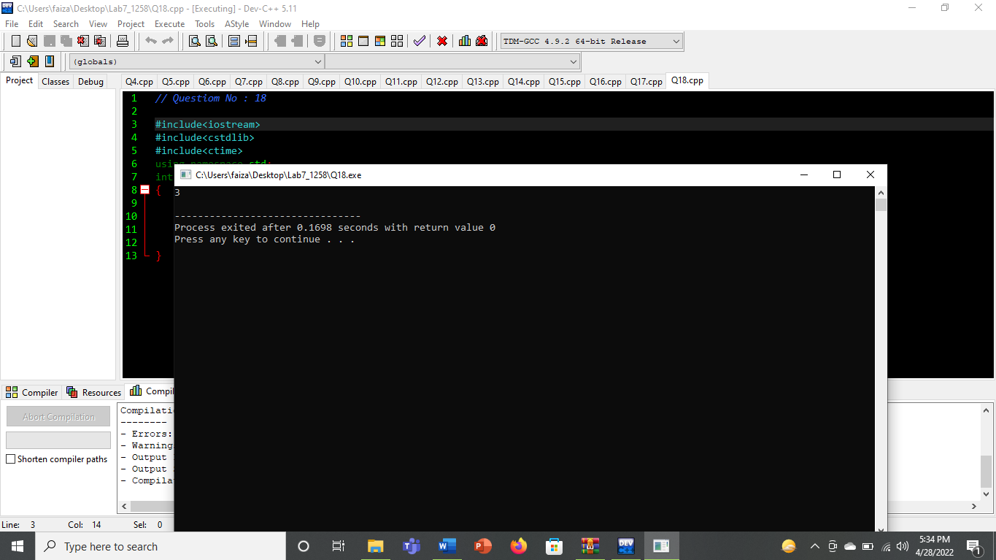

# Question No.4

## Input:

## #include<iostream>

## using namespace std;

## int largest(int a, int b, int c)

## {

## int largest;

## if((a>b)&&(a>c)){

## largest=a;}

## if((b>a)&&(b>c)){

## largest=b;}

## if((c>a)&&(c>b)){

## largest=c;}

## return largest;

## }

## float largest(float x, float y, float z)

## {

## float largest;

## if((x>y)&&(x>z)){

## largest=x;}

## if((y>x)&&(y>z)){

## largest=y;}

## if((z>x)&&(z>y)){

## largest=z;}

## return largest;

## }

## int main()

## {

## int a, b, c;

## cout<<"Enter three integers : ";

## cin>>a>>b>>c;

## float x, y, z;

## cout<<"Enter three float numbers : ";

## cin>>x>>y>>z;

## cout<<"The largest number is "<<largest(a,b,c)<<endl;

## cout<<"The largest number is "<<largest(x,y,z)<<endl;

## }

## }Output:

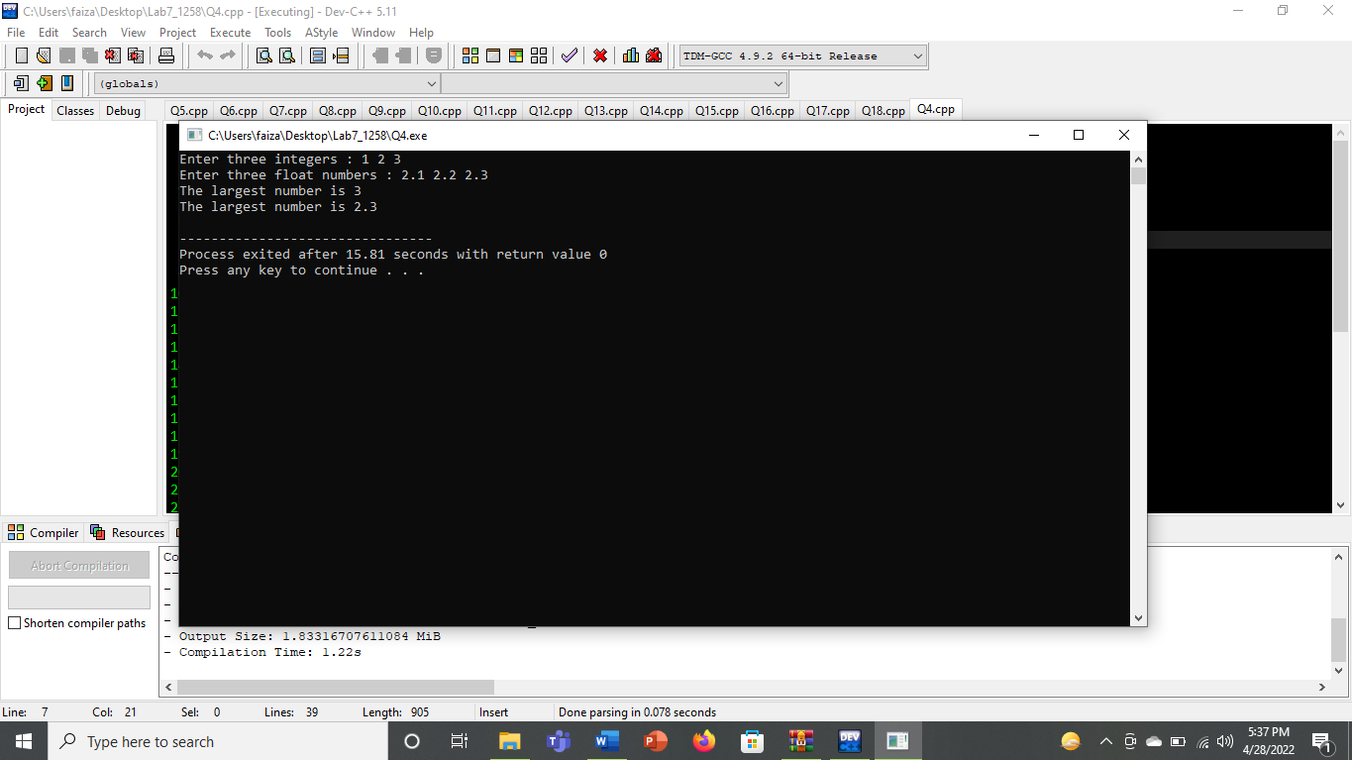

# Question No.5

## Input:

## #include<iostream>

## #include<conio.h>

## using namespace std;

## void input(int&,int&,int&);

## void output(int&,int&,int&);

## void input(float&,float&,float&);

## void output(float&,float&,float&);

## void input(char&,char&,char&);

## void output(char&,char&,char&);

## int main()

## {

## int num1,num2,num3;

## float Num1,Num2,Num3;

## char character1,character2,character3;

## cout<<"Enter three integers:";

## input(num1,num2,num3);

## output(num1,num2,num3);

## cout<<"Enter three floats:";

## input(Num1,Num2,Num3);

## output(Num1,Num2,Num3);

## cout<<"Enter three characters:";

## input(character1,character2,character3);

## output(character1,character2,character3);

## return 0;

## }

## void input(int &num1,int &num2,int &num3)

## {

## cin>>num1>>num2>>num3;

## 

## }

## void output(int &num1,int &num2,int &num3)

## {

## cout<<num1<<endl<<num2<<endl<<num3<<endl;

## }

## void input(float &Num1,float &Num2,float &Num3)

## {

## cin>>Num1>>Num2>>Num3;

## 

## }

## void output(float &Num1,float &Num2,float &Num3)

## {

## cout<<Num1<<endl<<Num2<<endl<<Num3<<endl;

## }

## void input(char &character1,char &character2,char &character3)

## {

## cin>>character1>>character2>>character3;

## 

## }

## void output(char &character1,char &character2,char &character3)

## {

## cout<<character1<<endl<<character2<<endl<<character3<<endl;

## }

## Output:

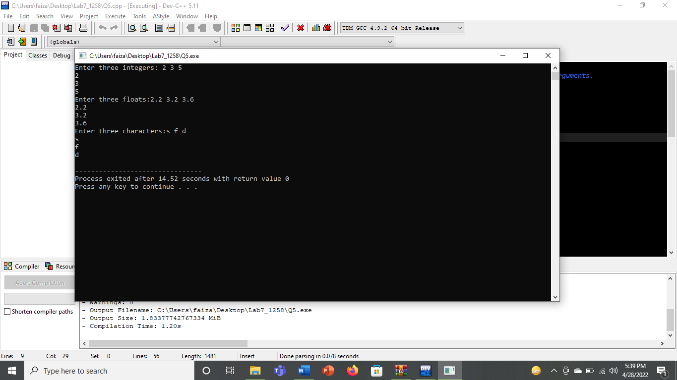

# Question No.6

## Input:

## #include<iostream>

## using namespace std;

## float swap(float a, float b)

## {

## float temp;

## temp=a;

## a=b;

## b=temp;

## cout<<"the value of a after awapping is a="<<a<<endl;

## cout<<"the value of b after awapping is b="<<b<<endl;

## }

## char swap(char x, char y)

## {

## char temp;

## temp=x;

## x=y;

## y=temp;

## cout<<"the value of x after awapping is x="<<x<<endl;

## cout<<"the value of y after awapping is y="<<y<<endl;

## }

## int main()

## {

## float a=9.1, b=5.4;

## cout<<"the value of a before awapping is a="<<a<<endl;

## cout<<"the value of b before awapping is b="<<b<<endl;

## swap(a,b);

## char x='a',y='b';

## cout<<"the value of x before awapping is x="<<x<<endl;

## cout<<"the value of y before awapping is y="<<y<<endl;

## swap(x,y);

## }

## Output:

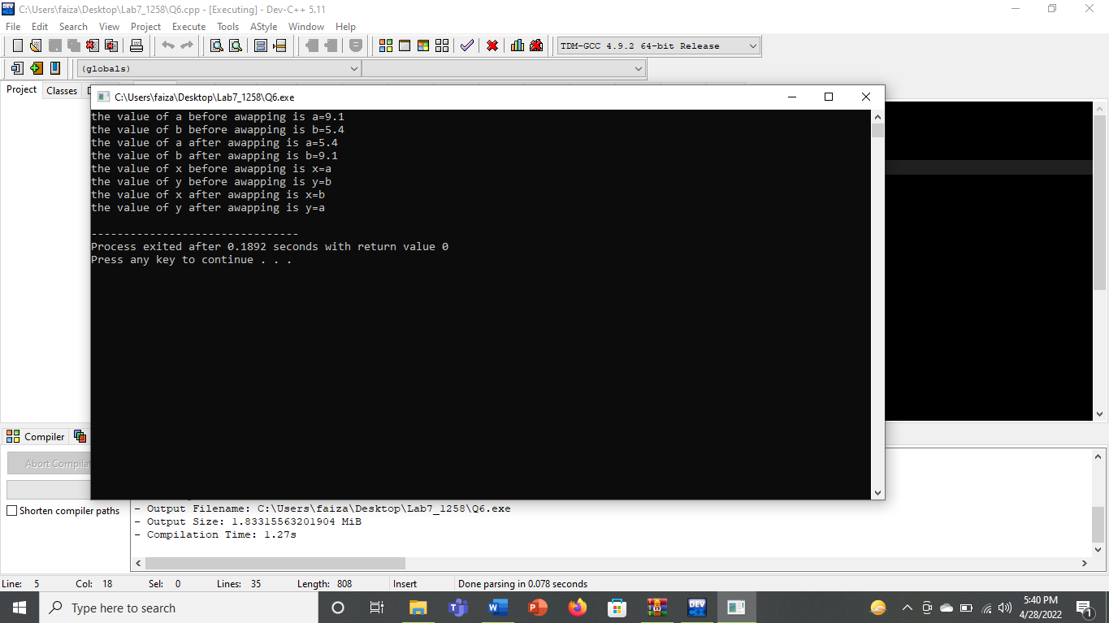

# Question No.7

## Input:

## #include<iostream>

## using namespace std;

## template <class ABC>

## void avg(ABC a,ABC b,ABC c,ABC d, ABC e)

## {

## cout<<"avg of 5 num is ";

## cout<<(a+b+c+d+e)/5.0;

## }

## int main()

## {

## cout<<"The avg of int numbers "<<endl;

## avg(1,2,3,4,5);

## cout<<"The avg of float numbers "<<endl;

## avg(2.4,5.4,6.6,8.8,6.4);

## }

## Output:

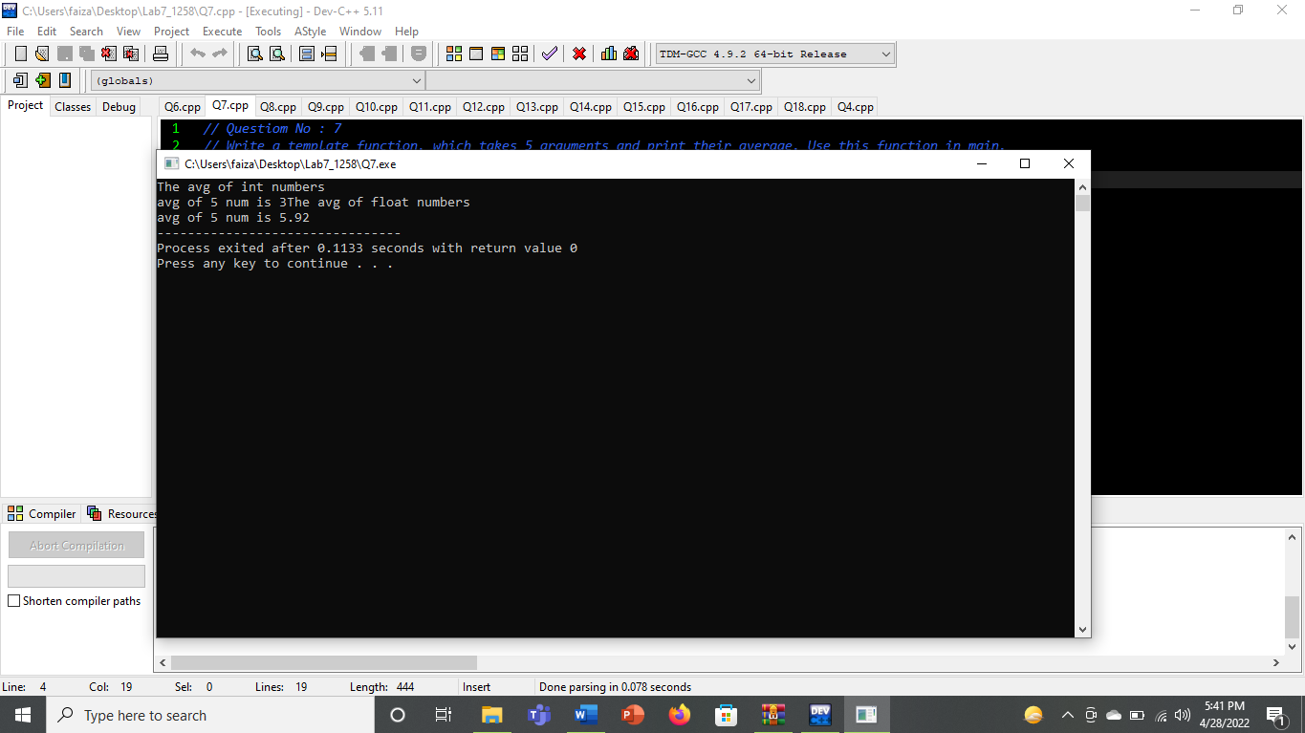

# Question No.8

## Input:

## #include<iostream>

## using namespace std;

## template <class ABC>

## void sum(ABC a,ABC b,ABC c,ABC d, ABC e)

## {

## cout<<"sum of 5 num is ";

## cout<<(a+b+c+d+e)<<endl;

## }

## int main()

## {

## cout<<"The sum of int numbers "<<endl;

## sum(1,2,3,4,5);

## cout<<"The sum of float numbers "<<endl;

## sum(2.4,5.4,6.6,8.8,6.4);

## }

## Output:

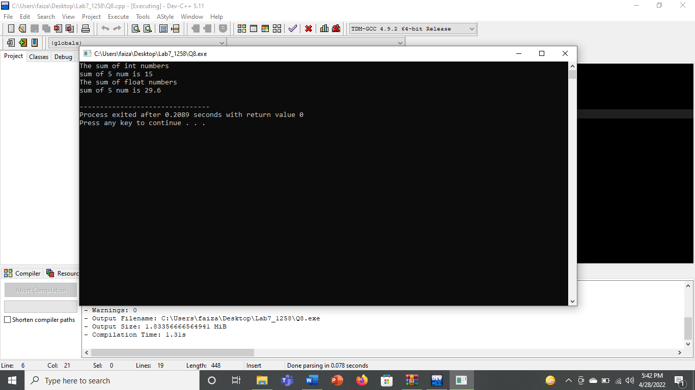

# Question No.9

## Input:

## #include <iostream>

## using namespace std;

## template <class wxy>

## void function(wxy a, wxy b,wxy c)

## {

## wxy small;

## small=a;

## if(b<small)

## {

## small=b;

## }

## if(c<small)

## {

## small=c;

## }

## cout<<small;

## }

## int main()

## {

## function <float>(2.3,3.4,4.5);

## }

## Output:

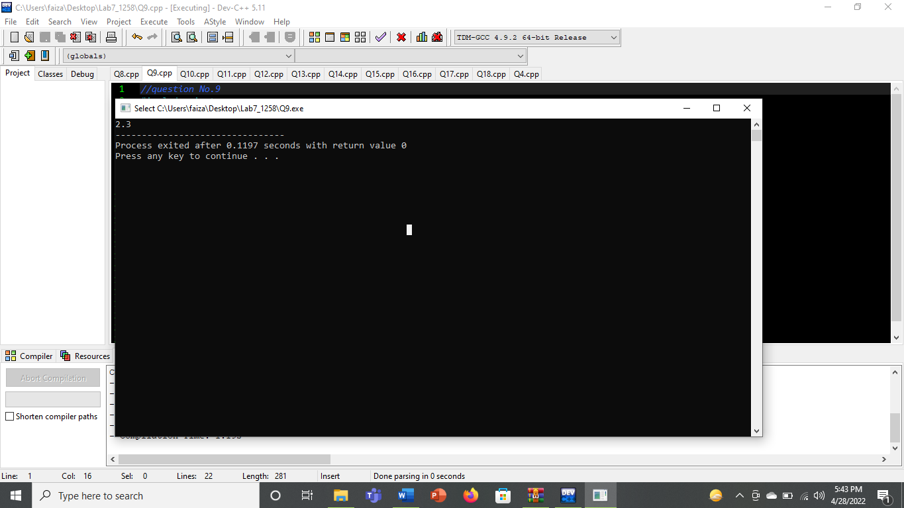

# Question No.10

## Input:

## #include<iostream>

## using namespace std;

## template <class ABC>

## void rad(ABC r)

## {

## ABC A;

## A=3.14*r*r;

## cout<< A;

## }

## int main()

## {

## cout<<"the area of circle is ";

## rad(22.5);

## 

## }

## Output:

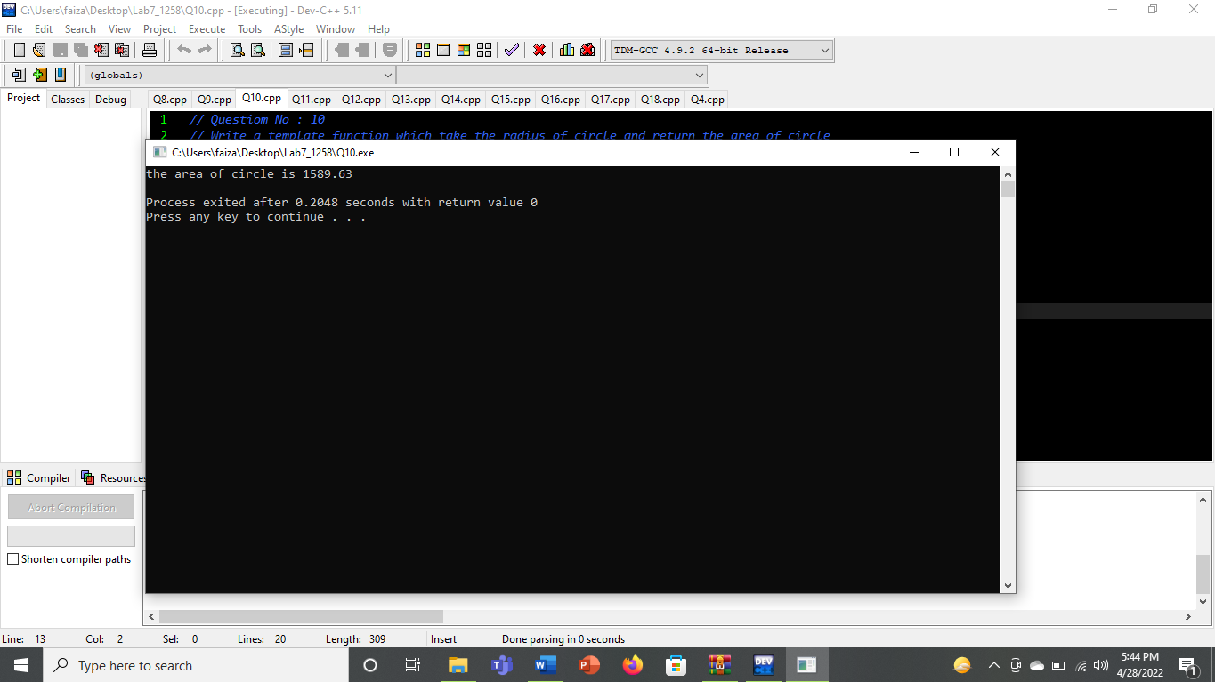

# Question No.11

## Input:

## #include<iostream>

## using namespace std;

## template <class abc>

## void swap(abc a, abc b)

## {

## abc temp;

## temp=a;

## a=b;

## b=temp;

## cout<<"the value of a after awapping is a="<<a<<endl;

## cout<<"the value of b after awapping is b="<<b<<endl;

## }

## int main()

## {

## 

## swap(3.4,5.5);

## cout<<endl;

## swap('s','x');

## }

## Output:

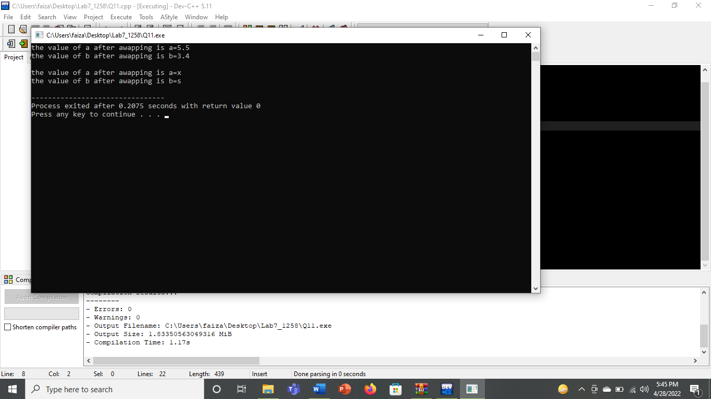

# Question No.12

## Input:

## #include"myheader.h"

## using namespace std;

## int main()

## {

## cout<<"Sum = "<<add(1,2,3,4,5)<<endl;

## cout<<"Subtraction = "<<sub(15,4,2,5,1)<<endl;

## cout<<"Multiplication = "<<multi(2,4,3,7,1)<<endl;

## return 0;

## }

## Myheader

#include<iostream>

int add(int a,int b,int c=0,int d=0,int e=0){

return (a+b+c+d+e);

}

int sub(int a,int b,int c=0,int d=0,int e=0){

return(a-b-c-d-e);

}

int multi(int a,int b,int c=0,int d=0,int e=0){

return (a*b*c*d*e);

}

## Output:

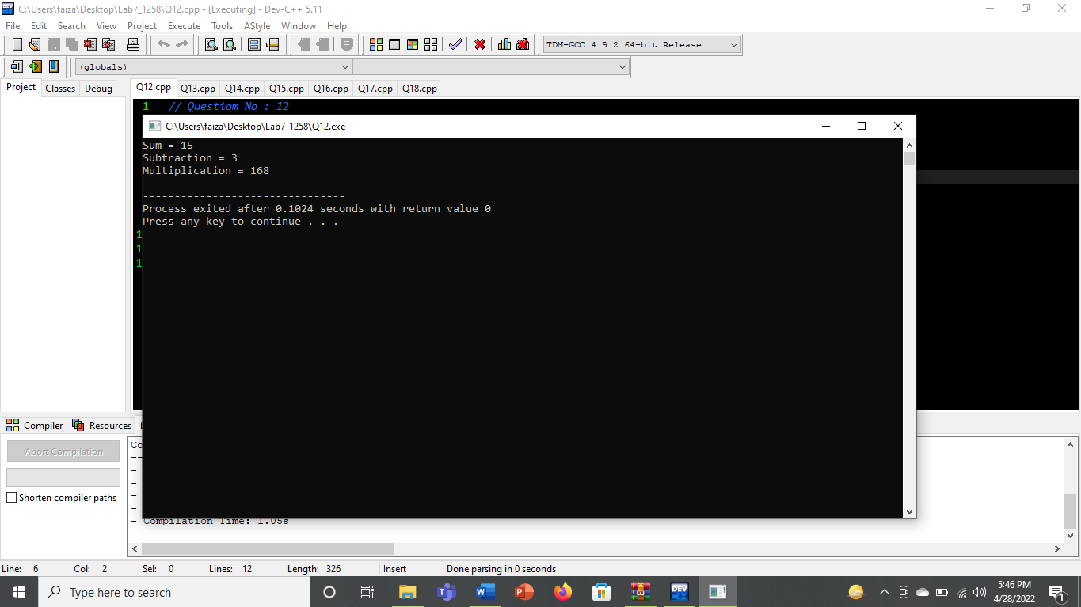

# Question No.13

## Input:

## #include <iostream>

## #include"Q_13.h"

## using namespace std;

## int main(){

## int num1,num2,num3;

## float numb1,numb2,numb3;

## char alpha1,alpha2,alpha3;

## inputandoutput(num1,num2,num3);

## inputandoutput(numb1,numb2,numb3);

## inputandoutput(alpha1,alpha2,alpha3);

## return 0;

## }

## Q13.h

## #include<iostream>

## using namespace std;

## int inputandoutput(int,int,int){

## int num1,num2,num3;

## cout<<"enter the three num: ";

## cin>>num1>>num2>>num3;

## cout<<"1st num "<<num1<<endl;

## cout<<"2nd num "<<num2<<endl;

## cout<<"3rd num "<<num3<<endl;

## }

## float inputandoutput(float,float,float)

## {

## float num4,num5,num6;

## cout<<"enter the three float: ";

## cin>>num4>>num5>>num6;

## cout<<"first num "<<num4<<endl;

## cout<<"2nd num "<<num5<<endl;

## cout<<"3rd num "<<num6<<endl;

## }

## char inputandoutput(char,char,char){

## char num7,num8,num9;

## cout<<"enter the three character: ";

## cin>>num7>>num8>>num9;

## cout<<"first num "<<num7<<endl;

## cout<<"2nd num "<<num8<<endl;

## cout<<"3rd num "<<num9<<endl;

## }

## Output:

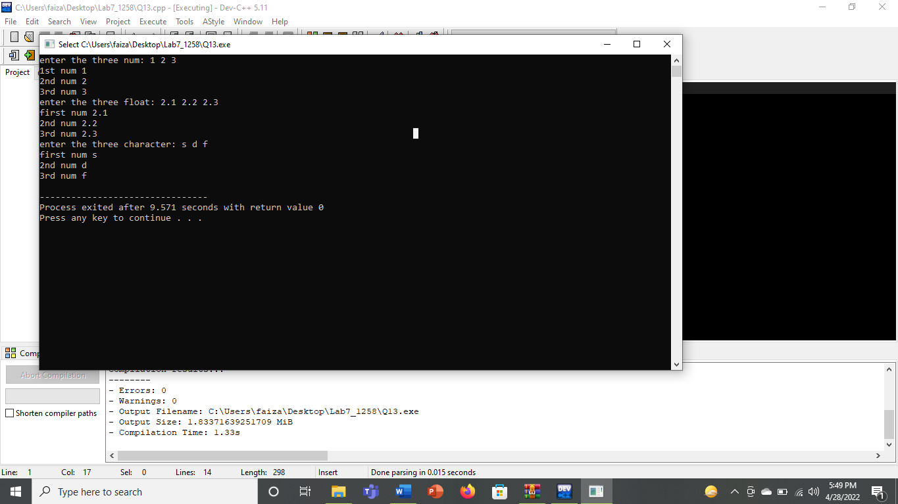

# Question No14:

## Input:

## #include<iostream>

## #include"math.h"

## using namespace std;

## int main()

## {

## cout<<pow(3,2)<<endl;

## cout<<sin(90)<<endl;

## cout<<sqrt(25)<<endl;

## cout<<tan(45)<<endl;

## int x=5,y=3;

## cout<<pow(x,y)<<endl;

## int a=90;

## cout<<sin(a)<<endl;

## int b=25;

## cout<<sqrt(b)<<endl;

## int c=25;

## cout<<tan(c)<<endl;

## }

## Output:

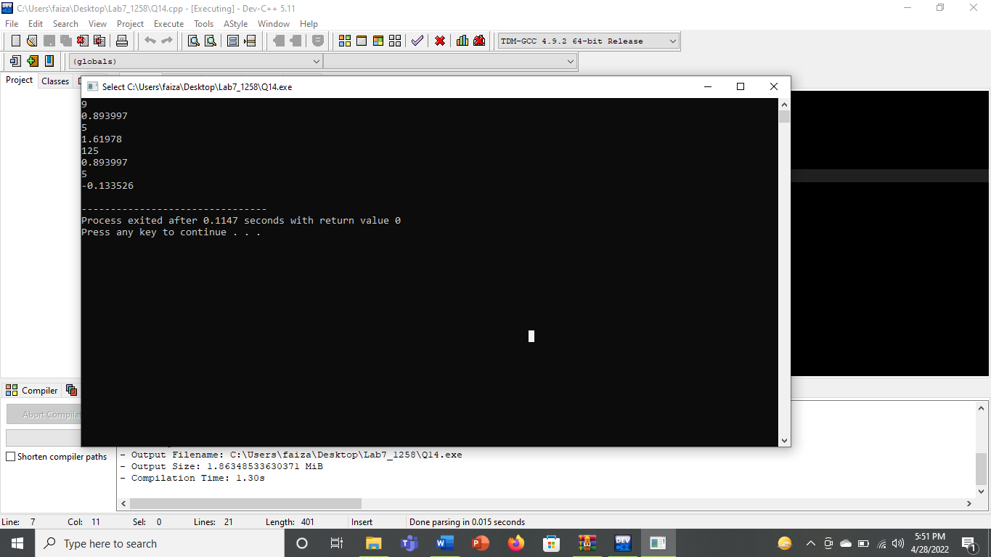

# Question No.15

## Input:

## #include<iostream>

## #include<cmath>

## #include<iomanip>

## using namespace std;

## int main()

## {

## int choicenumber;

## cout<<endl;

## cout<<"---menu---- "<<endl;

## cout<<"1"<<"\t"<<"power"<<endl;

## cout<<"2"<<"\t"<<"sin"<<endl;

## cout<<"3"<<"\t"<<"square root"<<endl;

## cout<<"4"<<"\t"<<"tan"<<endl;

## cout<<"Enter the choice number :";

## cin>>choicenumber;

## switch(choicenumber){

## int num1,num2;

## case 1:

## cout<<endl;

## cout<<"Enter the base num :";

## cin>>num1;

## cout<<"Enter the power :";

## cin>>num2;

## cout<<num1<<"^"<<num2<<" = "<<pow(num1,num2);

## break;

## case 2:

## cout<<endl;

## cout<<"Enter the value :";

## cin>>num1;

## cout<<"Sin "<<num1<<" = "<<sin(num1);

## break;

## case 3:

## cout<<endl;

## cout<<"Enter number :";

## cin>>num1;

## cout<<"Square root "<<num1<<" = "<<sqrt(num1);

## break;

## case 4:

## cout<<endl;

## cout<<"Enter number :";

## cin>>num1;

## cout<<"Tan "<<num1<<" = "<<tan(num1);

## break;

## default:

## cout<<"Invalid value :";

## }

## return 0;

## }

## Output:

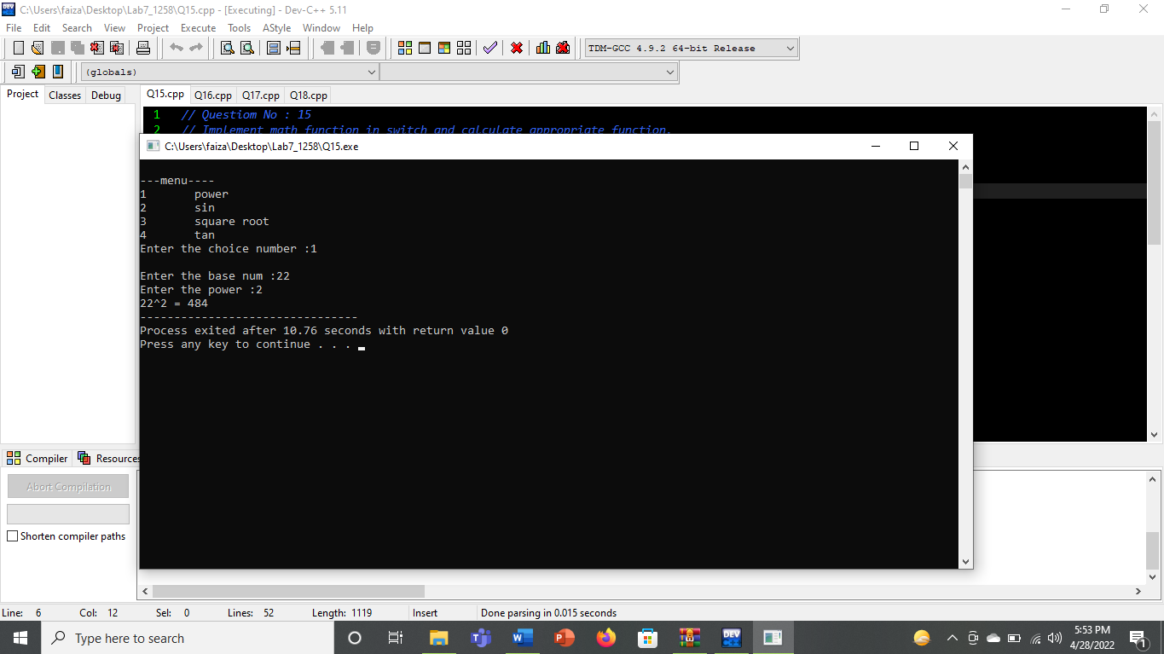

# Question No.16

## Input:

#include<iostream>

#include<cmath>

using namespace std;

int main()

{

int yc=3,xc=3,r=7;

int y;

for(int x=10;x<=15;x++)

{

y=yc+-sqrt(r*r-(xc-x)*(xc-x));

cout<<"value of y is "<<y<<endl;

}

}

Output:

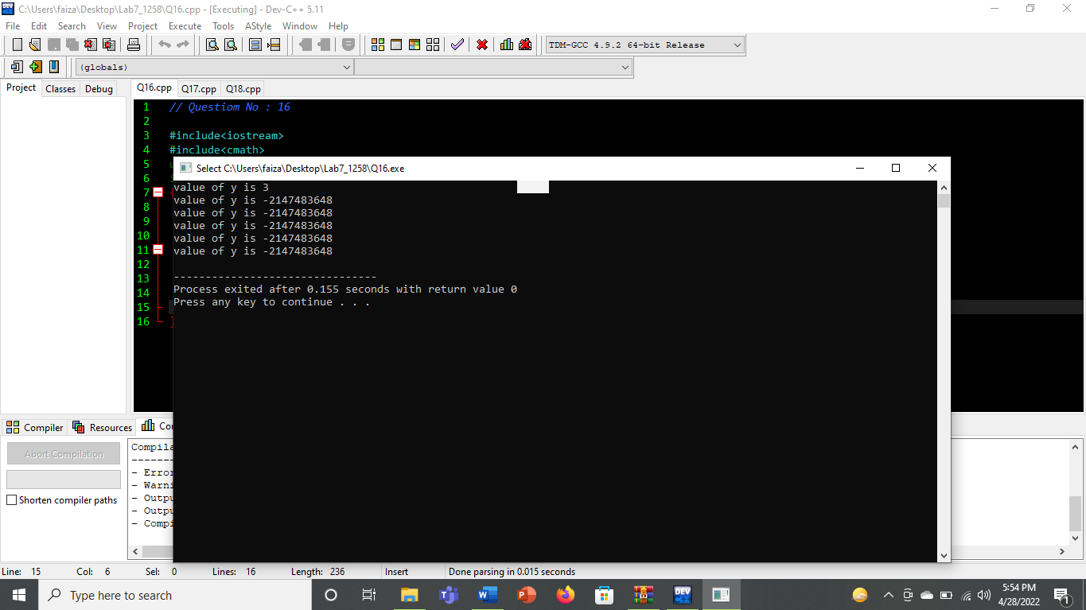

# Question No.17

## Input:

## #include<iostream>

## #include<cmath>

## using namespace std;

## int main()

## {

## int theta=90,Theta=120,xc=3,yc=3;

## float x,y,x1,y1;

## x=xc+sin(theta);

## y=yc+sin(theta);

## x1=xc+sin(Theta);

## y1=yc+sin(Theta);

## cout<<"Value of x for theta=90 is "<<x<<endl<<"Value of y for theta=90 is "<<y<<endl;

## cout<<"Value of x for theta=120 is "<<x1<<endl<<"Value of y for theta=120 is "<<y1<<endl;

## }

## Output:

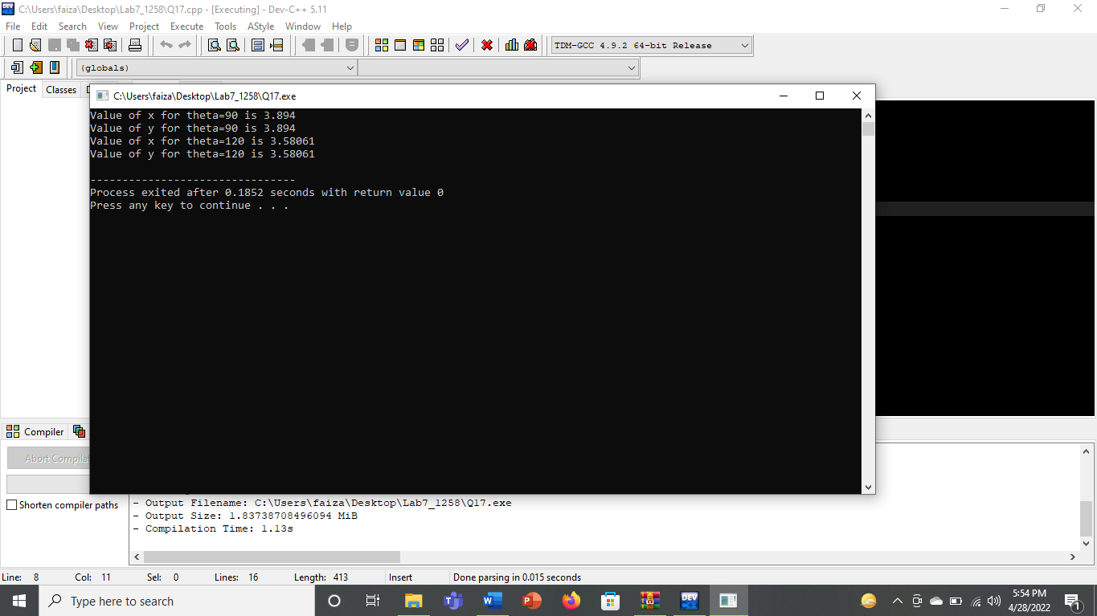

# Question No.18

## Input:

## #include<iostream>

## #include<cstdlib>

## #include<ctime>

## using namespace std;

## int main()

## {

## srand(time(NULL));

## int randvalue=1+rand()%6;

## cout<<randvalue<<endl;

## return 0;

## }

## Output:

